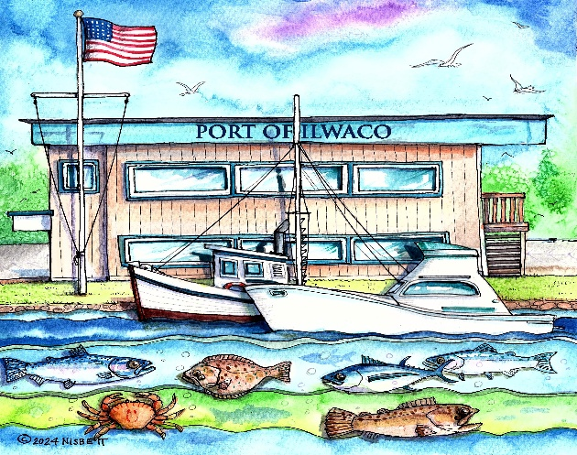
PORT OF ILWACO

P.O. Box 307
Ilwaco, Washington
98624

Manager
Tina Hayes
Area Code 360
Phone 642-3143
FAX 642-3148
www.portofilwaco.org

Commissioners
Alan Bennett
Mike Shirley
Butch Smith

NOTICE OF REGULAR MEETING CANCELLATION

NOTICE is hereby given that the Port of Ilwaco Board of Commissioners regular meeting, which was scheduled to begin at 3:00p.m. on Monday, November 17, 2025, at the Port of Ilwaco Conference Meeting Room has been cancelled due to no quorum.

