PORT OF ILWACO
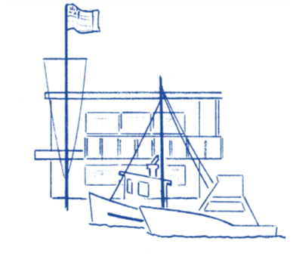

Notice of Special Meeting

NOTICE is hereby given that the Board of Commissioners of the Port of Ilwaco will be holding a “Special Meeting” October 22, 2025, which will begin at 9:00 am. This meeting will take place at the Port of Ilwaco meeting room, located at 165 Howerton Way, Ilwaco WA 98624.

The Port of Ilwaco has provided an alternative option to attend our public meeting via conference call until further notice.
This hybrid meeting will be held using Zoom. Please copy and paste the link below to join:
https://us06web.zoom.us/j/83779087802?pwd=bzcyZXRLb2xCVnBWWEZGRVJRRHRFZz09
Join by calling: +1(253)215-8782
Meeting ID: 837 7908 7802
Passcode: 2022
Agenda

- Approval of Resolution 25-1035 Review by HCA to participate in Washington State Insurance Plans
- Approval of Resolution 25-1036 Meeting time and day change
- Approval of Resolution 25-2037 Seizure of the Tlingit Princess
- Adjourn Special Meeting

